CS 255 System Design Document Template

This template lays out all the different sections that you need to complete for Project Two. Each section has guidance to prompt your thinking. You will need to continually reference the interview transcript as you work to make sure that you are addressing your client’s needs. There is no required length for the final document. Instead the goal is to complete each section based on what your client’s needs are. Remove this note when you are finished, and replace all bracketed text with the relevant information.

UML Diagrams

UML Use Case Diagram
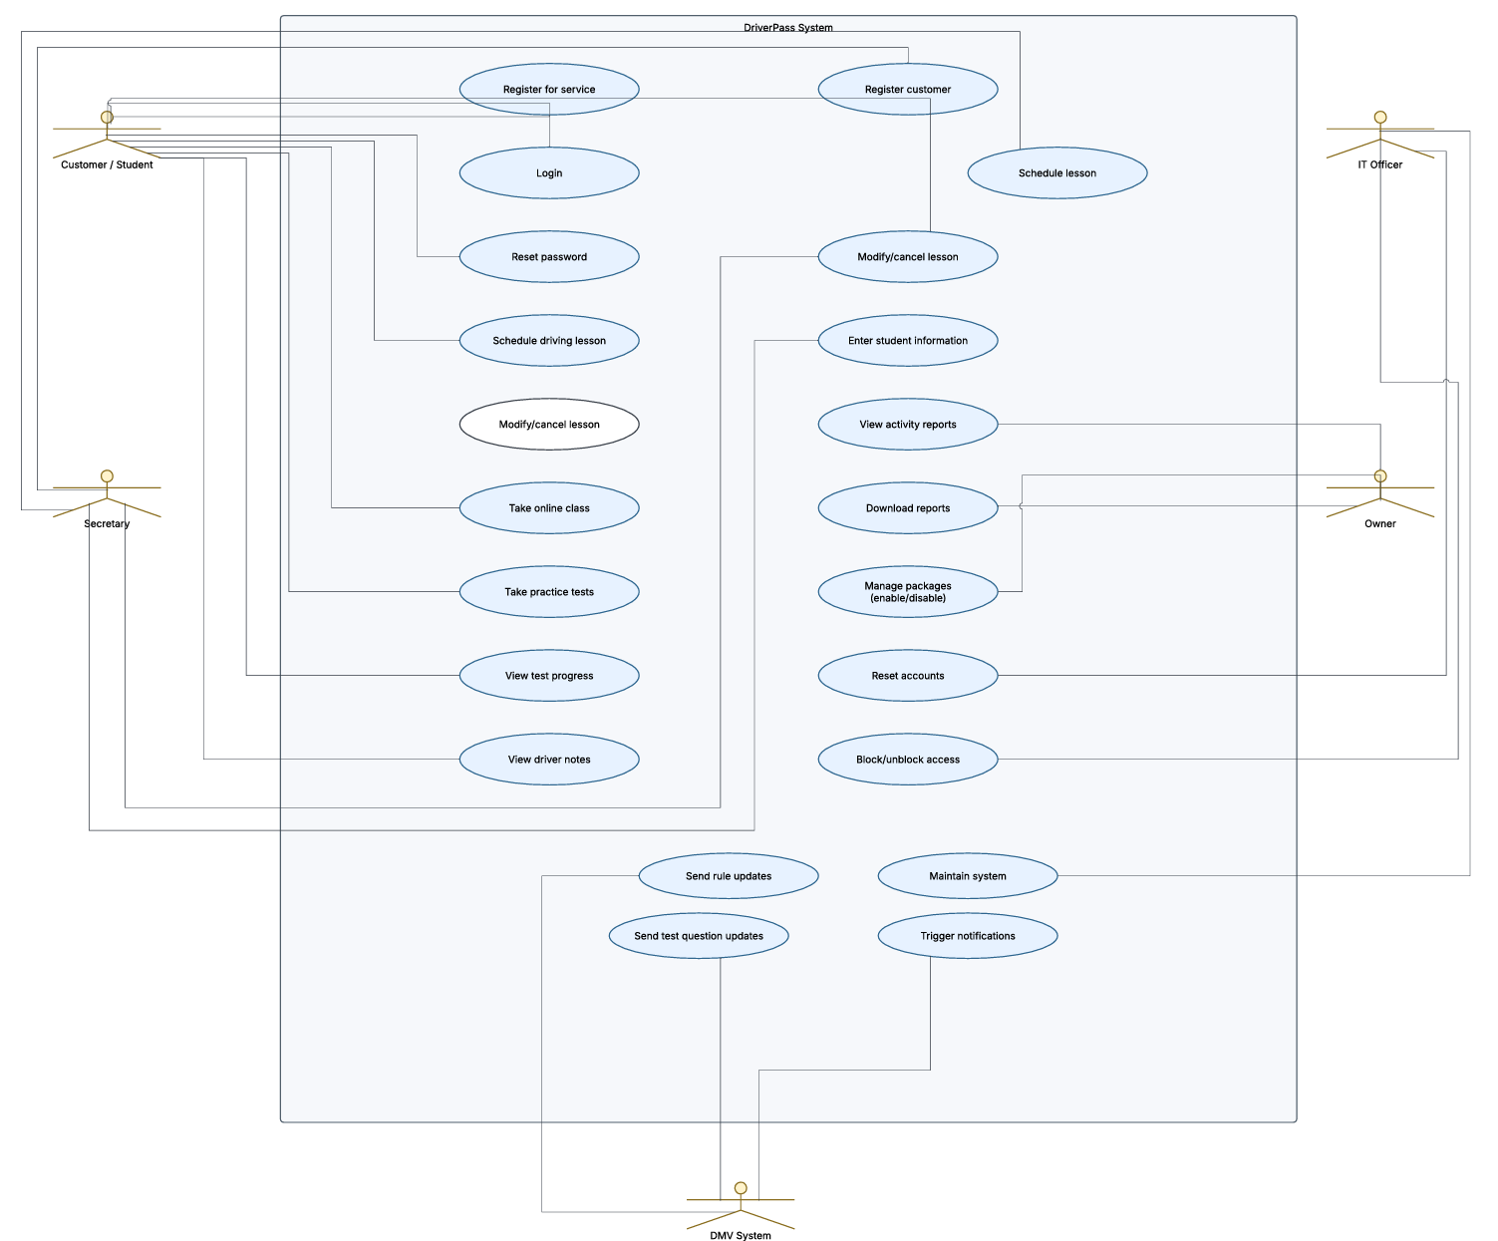

UML Activity Diagrams
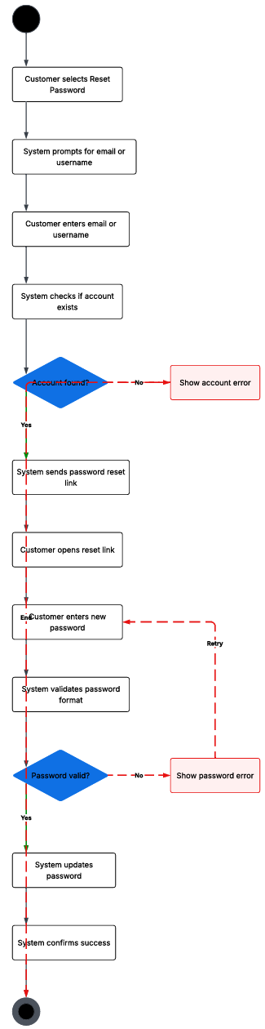
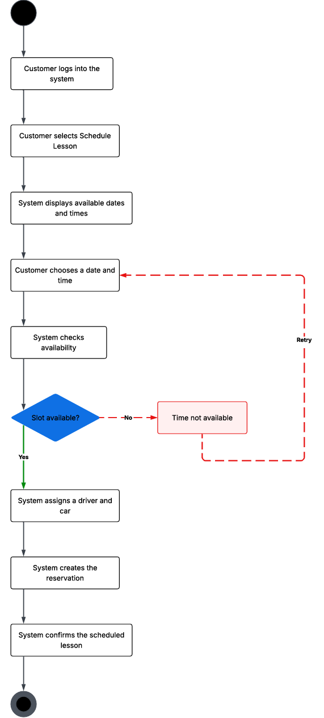

UML Sequence Diagram
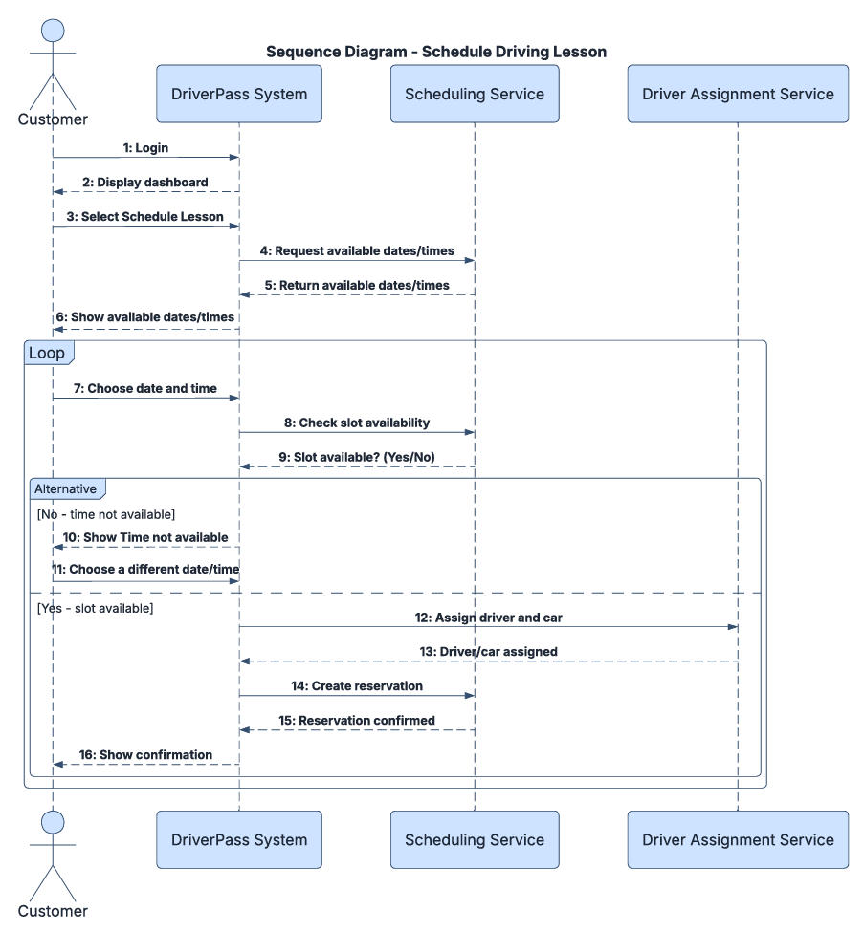

UML Class Diagram
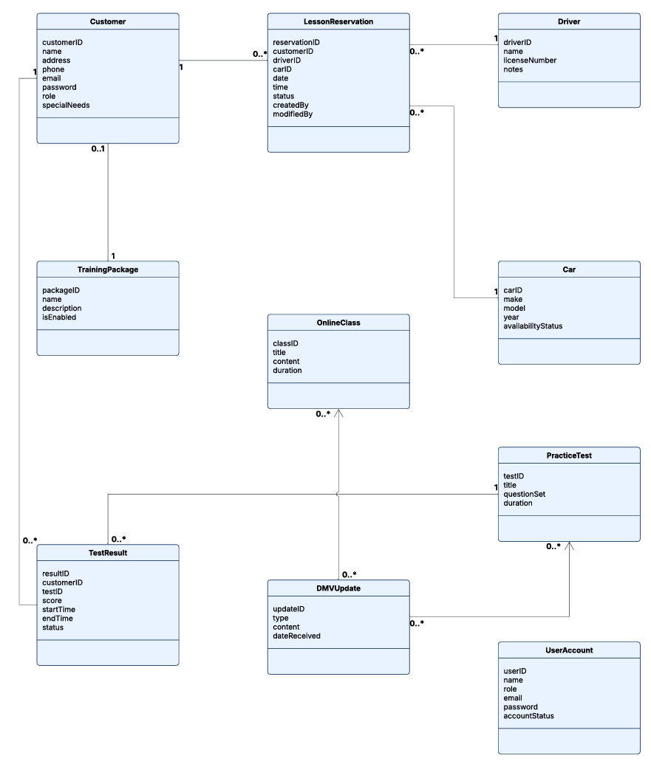

Technical Requirements
The technical requirements for the system require hardware, software, tools, and infrastructure.

The hardware requirements for the system are a server that can host a web application and a database along with all the systems that power it. It needs to have enough processing power to maintain performance levels when the system is being used by a large number of users. It also needs ample disk space to account for data being stored. The server needs to be connected to the internet to be able to serve the app to others over the web. Additionally, users will require a device that can access a web browser. The goal is for any client device capable of accessing the browser to be able to run the software.

The web application itself will require software to work such as JavaScript or Python, a database like SQL Server or PostgreSQL, and some sort of web server like Nginx. On the client side, they will require a web browser such as Chrome or Firefox. Finally, there will need to some security software for things like web traffic, communication, and authentication.

The tools required to build and maintain the system include things such as development tools like an IDE and Git for version control. The system would also require tools such as Lucidchart to make diagrams such as the ones in this document to help envision and build the system.

The infrastructure needed for this system are primarily a hosting environment such as Azure or AWS or an on-site server that can self-host the system. In addition to that, the system will need a way to send emails for things such as password resets. It also relies heavily on the internet both to run and on the client side to use the system, so networking is very important. It will also need security infrastructure to prevent things such as hacks and data leaks.

